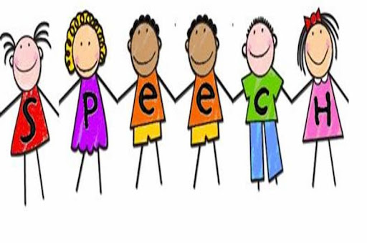
Dear Parents,
Welcome! My name is Connie Blanchard and I’m the speech-language pathologist at A. Brian Merry and I will be working with your child on speech and language skills this school year.
Many of you know me, but for those of you who don’t, here is a little bit about me. I was born and raised in Augusta. I attended Westminster Schools from kindergarten through eighth grade. I attended the Academy of Richmond County for ninth through twelfth grade and then went on to the University of Georgia, where I obtained both a bachelor’s and a master’s degree in education in Communication Sciences and Disorders. I began working for Richmond County Schools in August of 1995. I have been assigned to many schools over the years, but I have been at A. Brian Merry since August of 2000 and plan to stay at Merry until I retire. After 21 years, Merry is home!
This year I am assigned to serve students in the GNETS setting and two private schools as well as Merry. This means I am not full time at Merry, but it is my home base and I will be at Merry most of the time. If you need to reach me with questions or concerns, the best way is either email or text since I cannot answer my phone when I am with students. If you are new to Merry, please let me know your preferred method of communication (either email, text, or phone) so that I can contact you in the event of school closure. If your student was at Merry last year, I should have all of your contact information unless it has changed. I do ask that if you text or call me, please do so only between the hours of 7:00 am through 7:00 pm, Monday through Friday. You can email me anytime, the first thing I do when I get to school is check my email. We also have a Facebook page called “Merry Speech” that is a private group for parents of my students. While we were out for Covid, I did some videos explaining some of the things we work on in speech that may be helpful to you, so feel free to request to join our page. I also have a page on the Merry website and I am going to try to do better about updating it more often!
I am excited about a new year of speech and language activities! Since we just finished the 2020 Olympics (a year late) and in February the winter Olympics will begin, we are focusing on a sports theme in speech this year. We will be learning about sports and athletes from around the world while working on the speech and language goals in your student’s IEP.
Please feel free to contact me with any questions or concerns. I look forward to working with your student(s) this year!

Sincerely,

Connie Blanchard, SLP
Email: BlancCo@richmond.k12.ga.us
Cell phone: 706-799-7547

